Transport Contact

June 2012

Communication and information newsletter for paratransit service users

A new director at Transport adapté
Mario Gagnon introduces himself and praises Liette Vinet… see page 3.
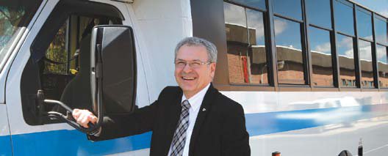

A dedicated team at your service!
You speak to them regularly, yet perhaps to you, they are only a name or a voice: call centre agents at Transport adapté play a crucial role worth looking at. Empathy is essential… see page 6

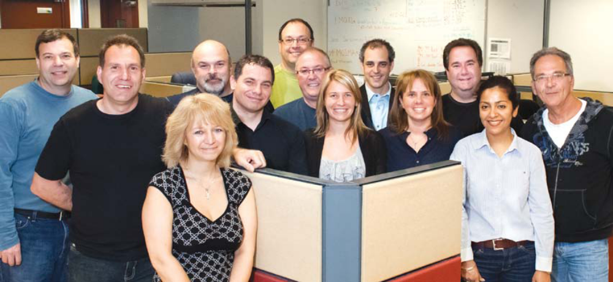

Yves, Michel, Sylvie, André, Mario, Michel, Daniel, ةmilie, Renaud, Chantal, Stéphane, Katiuska, Harald

THE STM AND DÉFI SPORTIF A WINNING TEAM!
The STM is proud to have contributed to the success of the 29th Défi Sportif AlterGo held from April 23 to 29. STM paratransit services covered most of the transportation needs by providing a shuttle service between the airport, hotels and different sports venues for athletes, accompanying personnel and volunteers.

What an honour it is to take part in this event year after year, and therefore promote a dynamic image of disabled persons through competitive sports. This partnership is in line with our universal access policy aiming for the social inclusion of persons with functional limitations.

Some very memorable moments full of emotion occurred last April 28, during the medal awards ceremony for swimming. “The Défi sportif plays an extremely vital role for thousands of Québec athletes. It was a real privilege to reward these swimmers who have trained for many months to come share an extraordinary experience. Although this event is the culmination of training, most certainly challenging at times, it provides athletes with lasting benefits throughout the year,” explains Renaud Drolet, Division Head of Customer and Partner Relations for Transport adapté.


Renaud Drolet applauds trophy winner

STAYING THE COURSE


My name is Mario Gagnon. I am the new director of the STM’s Transport adapté. For my first contact with you as the director, it would be appropriate to share my vision for paratransit. But before talking about me, I will rather salute the person I am replacing and who was my boss: Liette Vinet.

The team “we”
I will use “we” in this text because, for Liette, the value of teamwork is present at all times and must come through in each of our decisions and actions. For her, the “we” not only refers to the commitment of all employees to quality customer service, but above all includes customers as full members of our organization who have a say about the future of Transport adapté.

It is for these reasons, among others, that since her arrival in September 2009, we have conducted customer surveys, group meetings, and have consulted with advocacy groups for the disabled and the community who represent our overall customer base.

The “we” aware of the challenges awaiting us
It is only through attentive listening that we have come such a long way in the last three years and that we are aware of what remains to be achieved. The close ties with our customers, our employees, leaders in the disabled community, workers in the healthcare system, social services and the taxi industry, enable us today to have a plan that dictates the heading we must maintain to pursue our mission with ongoing improvement in mind.

Liette, “we” thank you and “we” will continue
There, I have introduced myself as the new director who will continue what we have built together, with our heart and with a passion that identify and unite us in our mission that is Transport adapté.

Mario Gagnon, Director, Transport adapté

ALWAYS BE PREPARED FOR FARE CONTROL

Since the OPUS card was first introduced, STM inspectors may check if you have a valid transit fare at any time during travel.

When you board a minibus or taxi, please keep in mind that:
Your OPUS card must contain a valid monthly or weekly pass.
OR
The required cash fare must be paid to the driver when boarding the vehicle.
OR
Your magnetic card must be given to the driver when boarding the vehicle.

The driver will record your method of payment (OPUS card, cash payment or magnetic card) on his trip roster.

If your fare has not been paid, you may receive a fine through the mail. The amount may range between $100 and $500, as stipulated in the STM R-105 By-Law.

If you are the customer’s legal guardian, the fine will be attributed to you and will be issued in your name.

Are you the customer’s legal guardian?
As guardian, you must ensure that the person in your care travels with a valid fare so that payment can be made.

In order to update our paratransit (Transport adapté) customer files, we must ascertain that legal guardians responsible for customers are clearly identified. If customer information has changed, please notify paratransit (Transport adapté) customer service at the following number: 514-280-8211, option 4. This updated information is important since you will be the first person contacted if necessary.

AFTER 4 YEARS, YOUR OPUS CARD WILL EXPIRE!

You may have noticed the information campaign that has been running for a few weeks now about the OPUS card reaching its expiry date. The first OPUS cards without photo identification that were introduced four years ago and used within the regular transit network are due to expire and must be replaced.

Since most paratransit customers started using the OPUS card in 2009, their cards should normally only expire in 2013. If you wish to verify your card’s expiration, you can do so by visiting the website carteopus.info where you can find out how to obtain your new card, if required, at no cost. Also, the next time you add transit fares on your card, take the opportunity to check your card’s expiration date.

Gradually, all OPUS cards will come to expiration. However, this situation only concerns cards without photo identification (regular fare) where the expiration date is not indicated on the card as opposed to reduced fare cards with photo identification.

As a paratransit customer, you need not worry about your OPUS card as there is still time before the card needs to be replaced!

TEAM PORTRAIT
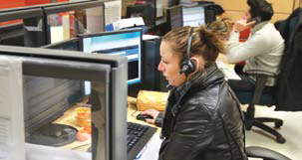
Reservations agents (option 1)
Reservations agents take your calls with requests for regular or occasional transportation or to modify existing reservations. They answer your questions about a variety of subjects, such as day camps, holiday activities, festivals and so much more !

They also advise you about reservations and transportation. Their ability to adapt to any situation enables them to handle requests from customers with a number of different functional limitations. The main concern of any reservations agent is correctly understanding the needs of a given customer, lending an ear, and providing reassurance so that a bond of trust can be established. Successful communications between an agent and a customer is essential for any passenger trip to unfold according to expectations.

Info-déplacement agents (option 2)
Info-déplacement agents inform customers about their regular schedule of transportation, process different types of cancellation, adjust return trip times for medical appointments that take longer, and reschedule any missed trips. They also keep in touch with dispatchers and service providers to check up on any late vehicles reported by customers or any other disruption that could prevent service from being delivered as planned. Agents must always be in problem-solving mode and the pressure is unrelenting!

As you can well imagine, calls to the info-déplacement line can generate anxiety, even dissatisfaction among customers, depending on the reason for the call. In that context, empathy is essential and agents must make sure they correctly understand the nature of the problem so that they may respond adequately, while being mindful of not causing any delays to other scheduled trips. To that end, we ask for your patience and understanding so that everybody comes out a winner. Indeed, for each and every one of your calls, there is someone trying to solve the problem to your satisfaction, without causing any dissatisfaction to anyone else. With a better understanding of the agent’s role, you can help us to better assist you!

MORE THAN 2000 OBSERVATIONS BY UNDERCOVER CUSTOMERS

An excellent way of improving the quality of service

In the past few years, Transport adapté has invested much effort into upholding the level of quality to which you have become accustomed and even surpass it. Results of the last survey among some 1018 paratransit users showed an overall satisfaction level of 93%, and we are very proud of that. However, improving the quality of our service is still a priority and a paramount commitment by Transport adapté
employees.

Among the various means at our disposal to assess the quality of service provided during your taxi rides, we have been using the observations made by undercover customers since September 2010. Since then, more than 1000 observations are carried out each year. Some 23 aspects of service are measured during these observations. In fact, every aspect of the client experience, from pick-up to drop-off, are assessed. Undercover customers answer a questionnaire by providing objective and factual information about what they saw during their ride.

Analyzing the results enables us to identify specific actions to be taken to further improve the quality of service and we are already seeing progress in a number of areas. These encouraging steps are part of our plan for constantly improving the quality of our service, and we hope that you will notice the results when you travel with us.

Among our many ways of improving the quality of service and finding out what you think, a customer satisfaction survey will be held in June, as in past years. Results will be presented in an upcoming issue of Transport Contact.

What is an undercover customer?
An undercover customer is a fake client assigned by an agency to measure the quality of service.

AN EXPERIENCE THAT CHANGES YOUR POINT OF VIEW!

In collaboration with RAAMM (Regroupement des aveugles et amblyopes du Montréal métropolitain), specialists in spatial orientation and mobility from the MAB-Mackay Rehabilitation Centre held an activity to raise awareness among the general public last February 9 at Berri-UQAM station. Organized as part of White Cane Week, the activity’s goal was to make people take notice of those with low-vision who are on the move. As for the members of Transport adapté who took part in the activity, mission accomplished!

An office clerk, a minibus driver, a customer service adviser, and a paratransit supervisor were given the opportunity, either blind-folded or with a low-vision simulator, to try using a white cane, going up and down a staircase, and learning the techniques used by sighted guides. Not to worry, they were not left on their own, but were indeed accompanied by a specialist in orientation and mobility.

Members of the Transport adapté team were unanimous: nothing beats walking in the shoes of a person with low vision to really understand how to properly assist him or her. A learning experience none of them will soon forget !
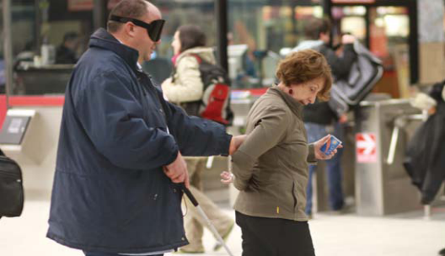
Driver Yves Poitras walks in the shoes of a visually-impaired transit user
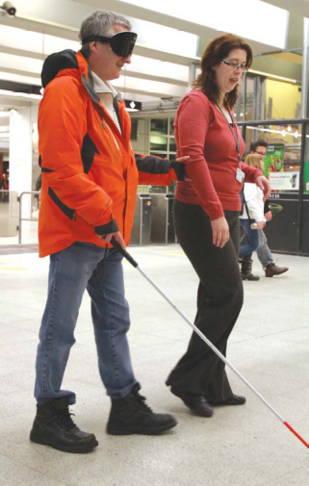
Office clerk Serge Raymond also lets his guide lead the way

UNIVERSAL ACCESS AT THE STM: VISIBLE ACHIEVEMENTS

In July 2009, the STM board of directors adopted a corporate policy on universal accessibility. Today, everyone agrees that if that policy’s implementation is a requirement for people with functional limitations, such action also provides added value for all transit customers. The STM therefore ensures that the principles of universal access are included in its projects, within the limits of available resources.

Working in collaboration with advocacy groups for people with functional limitations, the STM ensures that the needs of these customers are integrated into public transportation projects. Do you ever wonder how these projects become a reality?

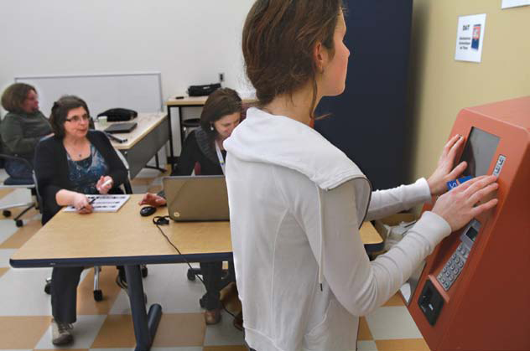

Testing the audio function on métro fare vending machines

Here are a few examples of visible achievements:
- Creation of information tools for customers using a wheelchair in the bus and métro network
- Routine purchase of low-floor buses with a flip ramp at the front and ongoing improvements to interior layout
- Universal access criteria included in the new bus shelter design
- Over 30 universal access measures integrated into the MPM-10 project
- Modifications to the interior layout of the 423 MR-73 métro cars with the addition of a designated area for wheelchairs
- Inauguration of three new accessible métro stations in Laval
- Installation of elevators in five stations of the existing métro network
- Increase in the number of reserved seats for the disabled and improved visibility for support bars inside all MR-63 métro cars
- Additional training for fare collectors, métro inspectors and bus drivers about the needs of customers with functional limitations
- Awareness campaign about reserved seats for pregnant women and other customers with limited mobility in the bus and métro
- Start-up of project to add an audio function to automatic fare vending machines in the métro

The STM has introduced a universal access development plan for 2012-2015. That plan is part of the STM’s 2020 Strategic Plan and takes into account the expectations expressed by partners during the Forum on Universal Access 2020 held in October 2010.

Last March, the STM consulted with Montréal associations for the disabled by presenting them with the plan for them to comment and improve upon. A review of events surrounding the publication of the plan will be featured in the next issue of Transport Contact. Stay
tuned!

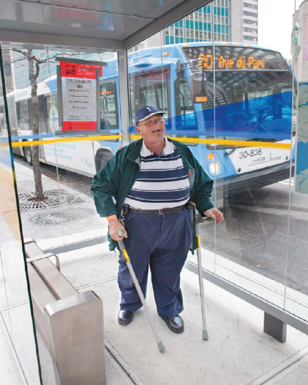
Integrating universal access criteria in new bus shelter design

Office des personnes handicapées du Québec
L’Office des personnes handicapées du Québec is a governmental agency created in 1978, following the adoption of the Act to secure handicapped persons in the exercise of their rights. In 2004, this Act was amended to become the Act to secure handicapped persons in the exercise of their rights with a view to achieving social, school and workplace integration.

With its mission to assist in the integration of persons with disabilities, the general mandate of the Office is to oversee the coordination of actions regarding the planning and dispensing of services for disabled persons and their families. The Office ensures, within the responsibilities conferred to the agency, that ministries and their networks, municipalities as well as public and private organizations pursue their efforts towards improving the possibilities for the disabled. The Office also coordinates planning endeavours and services provided to persons with disabilities and their families, enables and evaluates their school, professional and social integration. The agency informs, advises, assists and represents persons with disabilities on an individual and collective basis.

In addition, it is important to mention that, in 2009, the Quebec government adopted a policy fully ensuring the right to equality for persons with disabilities. The Office was designated to oversee planning and evaluation of this policy.

For more information, support or assistance for persons with
disabilities and their families:
Toll free telephone: 1 800 567-1465
Hearing impaired services: 1 800 567-1477
Web site: ophq.gouv.qc.ca

HELP US ASSIST YOU

Forget something?
Before exiting a paratransit vehicle, please ensure that you have retrieved all your personal effects so as to leave nothing behind. Unfortunately, too many items are forgotten on board.

Moving? Don’t forget your change of address!
Avoid unpleasant surprises with your regular schedule by making your address change as early as possible. The STM will adjust your schedule to your new home address. Call Customer Service at: 514 280-8211, option 4, or use the Change of address form in the Forms section of our Web site: stm.info/t-adapte.

Day camp
Submit yo ur request for transportat ion early! The day camp season is approaching. Reserve your child’s trips at least seven days in advance.

The reservation form is available from two sources: on our Web site: stm.info/t-adapte/formulaires, or from Customer Service: 514 280-8211, option 4. Return the completed form using one of the following methods: fax: 514 280-6313, or email: TA.Campdejour@stm.info. Call for confirmation two days prior to the first trip at the usual number: 514 280-8211, option 2.

If you’re using email, you must complete the form, save it on your computer and then send it to us at the above email address as an attachment. We will confirm your transportation times to you by email. Naturally, you can also make a request for camp transportation day via our call centre. Have a good summer!

Going away on vacation? Think of us!
Remember to temporarily suspend your regular trips before you leave. It’s quick and easy, with your choice of two options: using the automated services by calling 514 280-8211, option 3, or speaking with an agent by calling 514 280-8211, option 2. You can suspend your regular transportation schedule for a maximum of eight weeks. Call us as soon as you know your vacation dates.

You’ve reserved a trip and no longer need it? Please cancel it as soon as possible. By eliminating unnecessary trips for our vehicles, seats become available for other clients.

Requests for group transportation
Make your request at least 10 days in advance! The request form is available in the Forms section of our Web site: stm.info/t-adapte or by telephone from Customer Service: 514 280-8211, option 4.

Complete this form and send it to us by fax: 514 280-5317 or by email: groupes.ta@stm.info. Advise us prior to the departure date if the outing is cancelled. You must use a vehicle other than a paratransit vehicle to transport luggage that travellers cannot handle themselves.

OUR COORDINATES

A single number to remember
Telephone 514 280-8211

Requests for group transportation
Fax 514 280-5317
E-mail groupes.ta@stm.info

Teletype for hearing-impaired clients
(TTY) 514 280-5308

Requests for regular transportation and advance requests
for transportation
Fax 514 280-6313

Web Site stm.info

Customer Service
E-mail transport.adapte@stm.info

Preferred addresses
E-mail adresses.favorites@stm.info

Centre de Transport adapté
de la STM
3111, rue Jarry Est
Montréal (Québec)
H1Z 2C2

Transport Contact is an information newsletter published by the STM’s Communications and Customer Service department. May be reproduced if source is mentioned.

Editorial
Lydia Saint-Germain

Revision
Anne Charland

Translation
Linda Messmer

Graphic design
Cécile Dion

Photography
Guy Payment
Andrew Dobrowolskyj
Ronald Vaillancourt
(Défi sportif)

Pour obtenir votre bulletin Transport Contact en français, veuillez communiquer avec le Service à la clientèle au 514 280-8211 (option 4).
Nous vous en posterons un exemplaire avec plaisir.

