

Communication and information newsletter for paratransit service users

June 2014

IN THIS ISSUE

The new chairman of the STM impressed by our organization Le Support: An inspiring campaign Surveys: Where do the numbers come from? Aude Farley: The story of a swimmer

Let’s talk financing

SUSTAINABLE MOBILITY FOR ALL
Last February, Sylvain Gaudreault, the Transport Minister at the time, announced that financial aid for adapted transport would be increased in 2014 and maintained until 2020. Moreover, measures aimed at promoting universal accessibility to public transit services would be established.
While the announcement ensures the sustainability of the aid program from the MTQ and confirms a budget increase for one year, the fact remains that it does not respond to the major challenge we are facing: financing a steady growth of 7% per year in the number of trips.

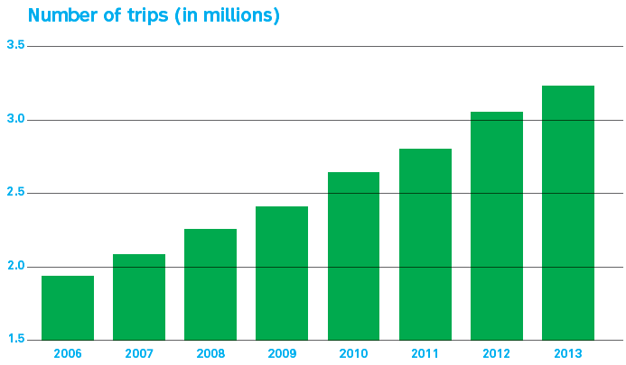

As this chart demonstrates, the number of trips rose by close to 64% between 2006 and 2013 to reach 3.23 million. We are therefore going to continue our discussions with the new government to make it aware ofm this reality.

In the meantime, our team is always looking for innovative ways to improve your trip experience. Currently in progress, the EXTRA project will enable us to manage growth thanks to better service planning.
You have told us that punctuality, waiting time and the availability of information on service status are on your list of priorities. The EXTRA project, which will take us into a more modern era, will provide us with all the necessary tools to advise you in real time of the arrival time of vehicles.

Until such time as we can give you a time frame, we will keep you informed on developments with this project, a major asset in the future of Paratransit.

EXTRA: for more information on this project, see our December 2013 issue.

AN ENJOYABLE VISIT
The chairman of the STM wanted to know more about the clientele and the operations of the paratransit service. So, in the company of Aref Salem, city councillor responsible for transportation on the Montréal Executive
Committee, Philippe Schnobb recently visited our installations.

The hours spent at Paratransit were very enlightening from the standpoint of the functioning of the service and the reality for employees as well as in relation to the challenges to be met, such as ridership growth and improvement in our quality of service.

During his visit, a mechanic confided that he loved his work because he could contribute in his own way to improving the quality of life of Paratransit clients.

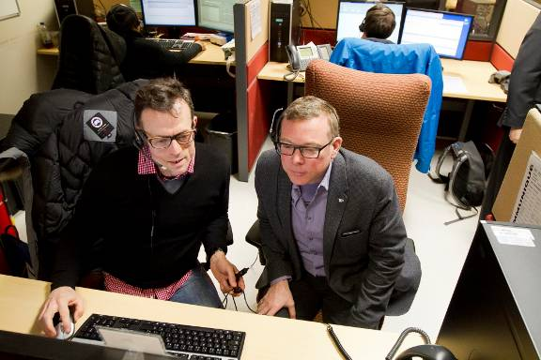

Mr. Schnobb handles a reservation in the company of clerk Alain Bouchard.

LE SUPPORT CAMPAIGN

As part of Semaine québécoise de la déficience intellectuelle, students from the group DÉFIS, a specialized class at Louis-Philippe-Paré school in Châteauguay, prepared an exhibition with the help of their teacher, Josée Trudel, and the organization, Le Support.

Following the collection of quotes and a photo session featuring the young people in the group, posters were unveiled in the school’s cafeteria. The reactions were so enthusiastic that several media picked up the story.
This project affects many more than just the students from the school, and we wanted to give greater visibility to this novel idea. We therefore contacted the organization that initiated the project to find out if it would be possible to display a few posters in our transportation centre. For examples: “Beauty attracts the eye, but personality captures the heart” and “The smile on my face does not mean my life is perfect - it only means
I appreciate what I have.”

This awareness campaign shown to employees demonstrates the significant and positive contributions of people with an intellectual disability. For this reason, Alain Mongrain, the person responsible for communications at Le Support, responded enthusiastically in the affirmative.

Funding for the organization comes exclusively from their donation boxes where people can deposit old clothes and other used items. Doing your spring cleaning? Seize the opportunity! Profits from the sale of these articles finance projects such as the one by this teacher showcasing the students of the group, Défis.

For more information, visit the site lesupport.ca.


Customer satisfaction

Where do the numbers come from?

Improvement in the quality of our services is a strategic priority and an essential commitment for Paratransit employees and for intermediaries in the taxi-based service.

Our methods of collecting this data are numerous: mystery clients, telephone surveys, on-the-road assessments, studies, peer evaluation, etc. The data from the results obtained is analyzed, and action plans are established. Each group of employees and each service is evaluated. Here are the principal methods used:

Mystery clients program

More than 1,000 evaluations carried out annually in all the taxi companies by fake clients.

On-the-road assessments by STM operations supervisors
Validation of the drivers’ operational procedures and punctuality using an evaluation grid inspired by the mystery clients program.

STM program for service quality standards
Evaluation of the courtesy, greetings and quality of information provided by call centre employees. Listening to recordings of telephone calls and evaluations carried out by fake clients.

Customer satisfaction survey by telephone
Evaluation of the overall level of satisfaction among clients. An outside firm conducts the survey among 1,000 randomly selected respondents representing all types of functional limitations. These would be active clients who had taken a minimum of 2 monthly trips in the last 6 months.

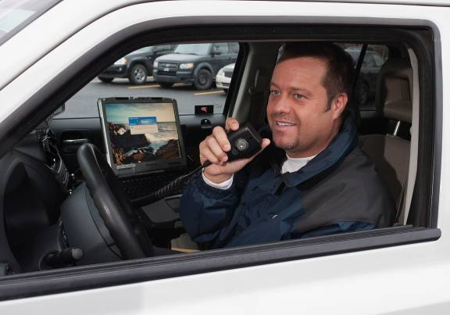

Over the past few years, we have invested a lot of effort in maintaining or even surpassing the level of quality that our clients expect.

Punctuality is at the heart of our priorities. For example, we took advantage of the installation of GPS on some of our minibuses to carry out a study, the results of which were communicated to our drivers during an information session.

We have also created a punctuality index and have set an objective for the year. A new poster campaign will allow us to communicate the results on a continuous basis.

THE TAXI SIDE

The mystery clients program aboard ordinary and accessible taxis enabled us to discover that prior to boarding, systematic validation of the client’s identity was not taking place. We specifically reviewed this important point during the ongoing training program with more than 1400 drivers.

The Info-taxi bulletin is one of the means used to communicate our expectations to them. Furthermore, the operations supervisors carry out direct interventions with drivers and individual meetings with intermediaries are organized monthly to follow up and discuss areas for improvement. Some companies have even initiated actions such as an internal disciplinary committee, a code of ethics, a document covering rules and guidelines, etc.

On a larger scale, we are also conducting benchmarks at the Canadian and international levels so as to compare the quality of our services and the technologies we employ.

THE BUS AND METRO NETWORK

The bus and métro network went through a few interesting transformations over the past several years. With winter over, why not take a quick tour
of the changes that now make it a little easier for people with reduced mobility to access buses and métro?

7 accessible metro stations
MONTMORENCY • DE LA CONCORDE • CARTIER • HENRI-BOURASSA • BERRI-UQAM • CÔTE-VERTU • LIONEL-GROULX

PRACTICAL ADVICE

Use buses equipped with an access ramp at the front to make your trips more reliable.

Consult the schedule for the arrival times of buses with a front ramp by using the following tools available to you:

The number 514 786-4636
The stm.info website
The mobile site
SMS
Android and iPhone applications
Printed schedules

For people with a motor limitation, ask the driver to lower the floor of the vehicle to sidewalk level to make it easier for you to get on or off.

To obtain the assistance service provided to clients in a wheelchair in the seven accessible métro stations, you must speak to the fare collector in the station.
The status of our bus and métro network is displayed in real time at stm.info. You’ll also find information there on the status of our elevators.

Planning a trip on the bus andmétro network? We can help you! 514 786-4636

More ACCESSIBLE SINCE 2013

All STM buses can now be lowered and are equipped with a front or rear ramp.

We have added 600 new accessible stops.

The planibus schedules show all the accessible stops. They are also easier to read.

In the event of bad weather, accessible service is maintained.

More freedom
More spontaneity
More flexibility

NEW BUS SHELTERS

Have you noticed? They’ve made their appearance on the bus network.

The design of the future bus shelters was conceived as part of a competition launched by the City of Montréal and the STM. An agreement was reached with Québecor to replace the great majority of the bus shelters in Montréal. Prototypes featuring screens provide access to practical information such as a map of the sector, bus schedules, the weather, news, etc. In addition, digital interactive bus shelters equipped with a gesture recognition screen are currently being tested on the network, the first in the world.

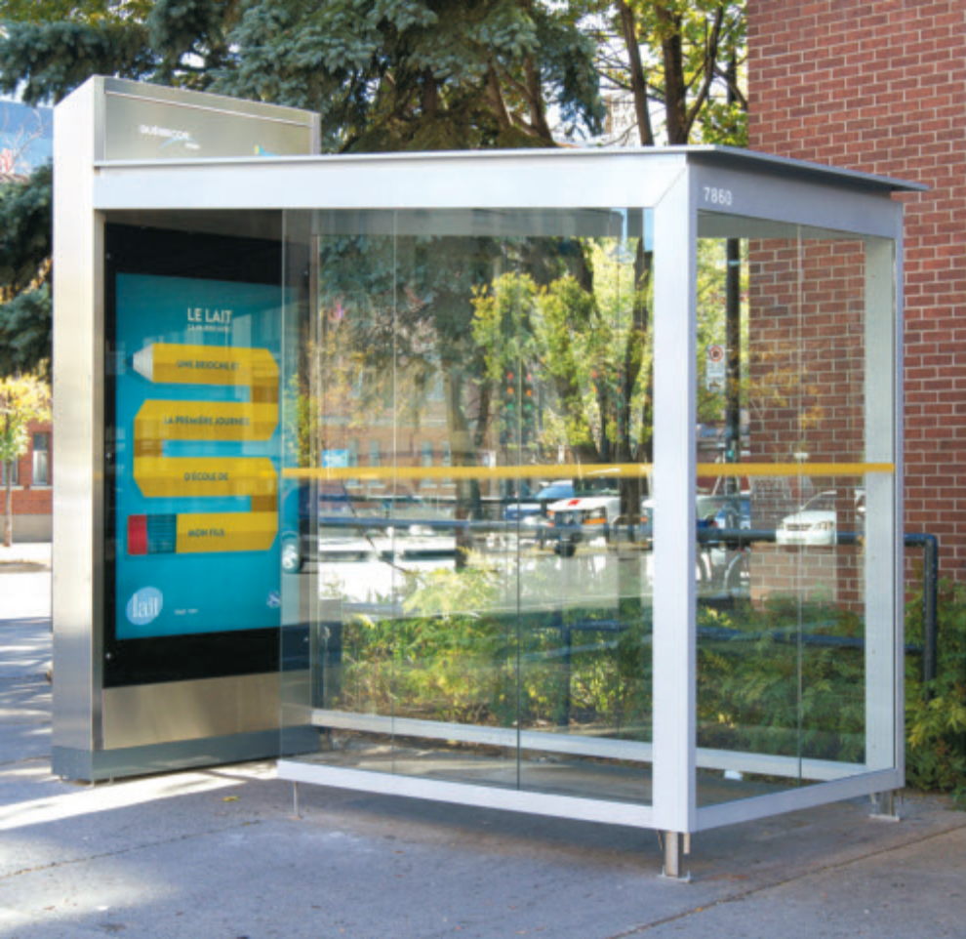

Chronicle: LIVING LIFE FULLY

It’s six o’clock in the morning. Aude Farley is at her window, ready for the transport that will take her to her swimming training. Wait a minute…isn’t she in a wheelchair? Yes, but that doesn’t stop her. “I’ve been swimming for close to 15 years”, confides Aude, who is now in her early forties.
“I was participating in this sport well before being diagnosed with multiple sclerosis. I continue to swim two mornings per week because it does me so much good!” Sport being a way of life for her, she had to adapt her methods due to the limitations imposed by her illness. “I place a buoy between my legs so that they float and I attach them together. I then propel myself using only my arms.” And we can tell you, she’s fast!

Once her training is done, Aude heads to work at TVA. “I co-ordinate voiceovers for television series (voices in French that are superimposed over the original English voices). I have them translated, I co-ordinate the recording of the voices in French and, finally, the post-production that leads to the finished product.” At the end of the day, paratransit takes her back home. “I hope I don’t forget the milk, because getting to the dépanneur in a wheelchair can be a real challenge.”

And what role does paratransit play in Aude’s life?

“For sure, I’d like to see certain improvements,” she suggests. “The famous half-hour window for arrival, for example. I’ve learned to deal with it, but I’d definitely appreciate more precision in the time of my transportation. That said, I think we are privileged to benefit from this service. For the price of a métro ticket, we have access to personalized transportation with attentive and patient drivers.”

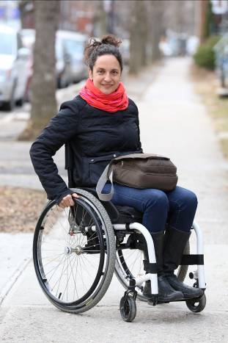

Tips from a paratransit pro

As she’s a regular client, we asked Aude to offer us a few tips to benefit as much as possible from paratransit. “First, a smile brings a smile. You have a better chance of obtaining friendly service if you display this attitude yourself. Next, reserve via the Internet: it’s what I do, and I recommend it. This way, the volume of calls that paratransit receives does not affect the handling of my request. Finally, you can now reserve seven days in advance, and I find that practical as well. I often rely on this service.”

AUDE THRIVES ON CHALLENGES

She uses paratransit for her regular trips. On the weekend, she sometimes sets herself a challenge: go to Jean-Talon market by conventional bus, for example. “I choose a day when I have the energy, and when I manage to take this outing I love, independently and spontaneously, I’m very proud!”

DÉFI SPORTIF

Each year, for the past 31 years, we have been involved in the Défi Sportif Alter Go as the official transporter. We provide transportation for the athletes and their attendants as well as volunteers by setting up a shuttle service (primarily minibuses and adapted taxis) from Montréal-Trudeau Airport, various hotels and competition sites.

The event brings together 4,600 elite and up and coming athletes with various disabilities from more than 15 countries. It’s quite a challenge for the planning team at paratransit, but a challenge so motivating and positive that it’s worth the effort! Drivers, clerks, operations supervisors and management are all delighted to participate in the success and promotion of this world class event!

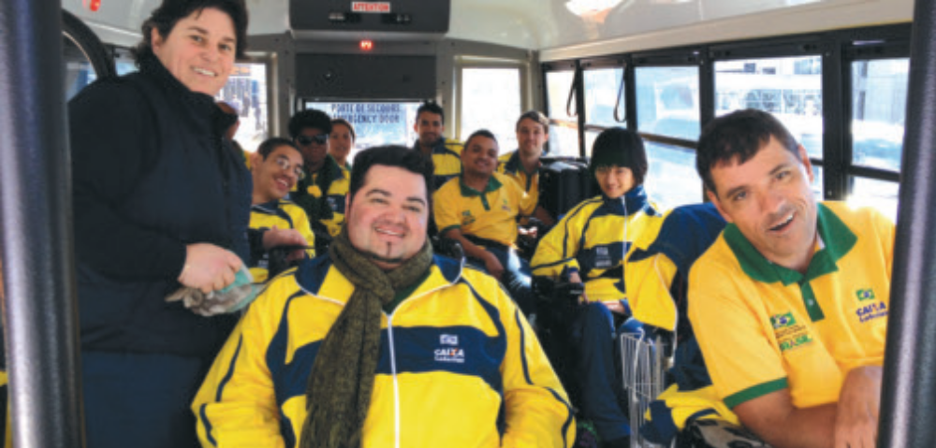

The STM is proud to encourage physical activity, social inclusion and universal accessibility. Its contribution to Défi Sportif Alter Go is obvious proof of this.



65 years old and OPUS card

Don’t forget that it’s important to show your OPUS identity card for all your trips with paratransit. In addition to serving as proof of admission to Transport adapté, this card allows you to load various transit fares for paratransit travel as well as on the bus and métro network.

You’ve celebrated your 65th birthday? You can now benefit from the 65+ reduced fare when the reduced fare reference appears on your Transport
adapté identity card. You must make a request to paratransit customer Service to receive a new card that includes the reduced fare reference.

You can load your OPUS fare card at points of salelocated in the various boroughs and cities in the Montréal agglomeration or at a fare booth or an
automatic vending machine in métro stations. Visit stm.info for the list of points of sale.
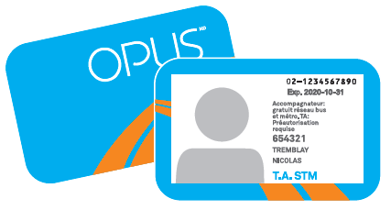

The perfect combo
Opus à l’année + Maestro

OPUS à l’année is a perfect solution for people who pay the full fare and don’t want a lot of bother. This annual program is offered to holders of a regular fare monthly CAM. Want to subscribe? Just get in touch with Transport adapté to have this type of subscription loaded onto your paratransit OPUS card.

You’ve been subscribed to the OPUS à l’année program for almost a year?

You can benefit from Maestro status and enjoy privileges on your trips. For example, you can have a friend travel with you for free every weeknight from 6 p.m. to 5 a.m. as well as all day Saturdays and Sundays. Once you are eligible for the program, you will automatically be contacted by the STM.

Did you know that the STM has a rewards program?

The MERCI program is targeted exclusively at STM public transit clients. Whether it’s through the mobile application or our website, offers from merchants are available to you every day. Restaurants, theatres, florists… there are discounts of all types for all tastes. And there’s even more. If you create your profile using the application, you’ll be able to receive personalized offers based on your interests. Find more information in the Offers and Outings section at stm.info.



HELP US HELP YOU LAST

Minute cancellations

If you are absent for an outgoing trip, the planned trips that follow (until your return home) will be cancelled. To keep your return trip, you absolutely must advise an agent at Info-déplacement (option 2) in the 60 minutes following the scheduled departure time for your outgoing trip.

MOVING?

Avoid unpleasant surprises with your regular schedule by making your address change as early as possible. The STM will adjust your schedule to depart from your new residential address.

Call Customer Service at 514 280-8211, option 4 or use the Change of address form in the Request Forms section on our site stm.info/en/
paratransit.

IS YOUR CHILD IS GOING TO SUMMER CAMP?

Reserve trips for your child at least seven days in advance by proceeding as follows:

First obtain the reservation form either on the site stm.info/t-adapte/
formulaires, or from customer service by calling 514 280-8211, option 4.
Then return the completed form by fax to 514 280-6313, or by e-mail to
TA.Campdejour@stm.info.

For confirmation, call the usual number two days prior to the first trip:
514 280-8211, option 2.

If you use e-mail, complete the form and send it as an attachment. We will then confirm your transportation times by e-mail.
You can also make this transportation request for day camp through our call centre.

Have a good summer and happy camping!

LEAVING ON VACATION?

Before leaving, remember to advise us of the temporary interruption in your regular trips. You can interrupt trips in a regular schedule for a maximum period of eight weeks. You have the choice of using SIRTA, the voice service at 514 280-8211, option 3, or speaking directly to an agent, option 2.

Reserve or cancel your regular or occasional trips using SIRTA, our Internet-based information and reservation system. It’s the quickest way! Go to the Paratransit web page and click on Reserving online.

PLANNING A GROUP TRIP?

Make your request at least 10 days in advance! The form is available in the Request Forms section of our stm.info site. Complete it and send it to us by fax at 514 280-5317 or by e-mail to groupes.ta@stm.info. You can also call Customer Service at 514 280-8211, option 4.

LUGGAGE?

The driver can refuse to carry out a trip if you have luggage or parcels that you cannot handle yourself. Note that the only addresses where luggage transport is permitted are the following:

Montréal-Trudeau Airport

Central Station (train) – 895 De La Gauchetière Street West

Dorval Via Rail station – 755 Montréal-Toronto Blvd., Dorval

Montréal’s central bus station (Voyageur Terminus) –
1717 Berri Street, Montréal

Papillon Day Camp – 7275 Sherbrooke Street East, posts 24-25

Mégabus Terminus (facing the main door) – 997 Saint-Antoine West, Montréal

Don’t have a password?
Ask for one at 514 280-8211, option 4.

All paratransit employees and drivers Transport adapté wish you a very pleasant summer!



Our contact info

Just one phone number to contact the paratransit centre
Telephone: 514 280-8211

Requests for group trips
Fax: 514 280-5317
E-mail: groupes.ta@stm.info

Teletypewriter (TTY)
514 280-5308

Requests for regular and occasional trips
Fax: 514 280-6313

Web site
http://www.stm.info/en/paratransit

Customer service
E-mail: transport.adapte@stm.info

Favourite addresses
E-mail: adresses.favorites@stm.info

Centre de Transport adapté de la STM
3111 Rue Jarry East
Montréal, Quebec
H1Z 2C2

