Transport Contact

Spring 2024

# In this issue :

1. Our people deserve respect, too.

2. New signs in vehicles

3. Fares increasing an average of 3% since July 1

4. Honouring Serge Poulin (1962‒2024)

5. Making the métro more accessible for all

6. When you book a trip

# Our people deserve respect, too.

That’s the message of a recent print ad campaign deployed in the bus and métro network.

We wanted to share this message with you because our frontline teams have noticed an uptick in hostile behaviour lately. The ads feature real people who work different jobs in our networks, including the paratransit network.

Although most of our customers are kind and respectful toward our teams, it’s important to understand that even small acts of hostility, when repeated dozens of times a day, can have a huge impact on our employees.

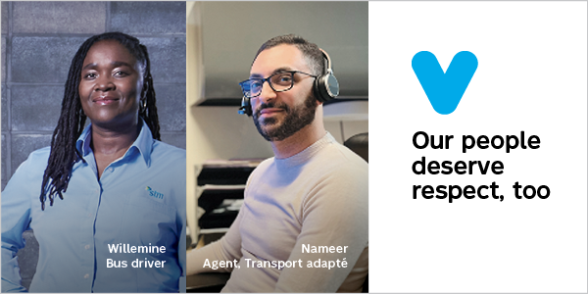

Photo 1 : photos de Willemine, Bus driver, and Nameer, Agent, Transport adapté, and our theme « Our people deserve respect, too. »

# 

# New signs in vehicles

# You may have noticed a small sign posted in your paratransit vehicle recently with pictograms and text explaining the rules of the STM’s paratransit network. They are:

* Drivers must accompany customers as they get into the vehicle.
* Customers must handle their own bags at pick-up and drop-off.
* Customers must be ready for pick-up at the confirmed time. Drivers have 30 minutes to arrive, starting at that time.
* Drivers must accompany customers as they get out of the vehicle.
* Customer bags must not take up extra space in the vehicle.
* Drivers must provide customers with assistance as needed to fasten any safety features in the vehicle.

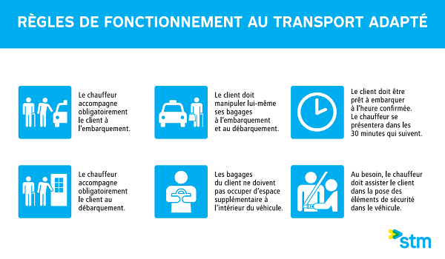

Photo 2 : The sign described in the text above.

# Fares increasing an average of 3% since July 1

# Here’s a look at this year’s indexation of public transit fares for paratransit, as announced by the Autorité régionale de transport métropolitain (ARTM).

# Same price for 1-trip, All Modes A fares.

# Slight increase for:

* Weekly, Monthly and 4-month, All Modes A fares
* All Modes AB and ABC fares

[See the full 2024 fare schedule for Paratransit on our website](https://www.stm.info/sites/default/files/pdf/en/a-tarifs-ta.pdf).

# Honouring Serge Poulin (1962‒2024)



Photo 3 : a photo of Serge Poulin

We were deeply saddened to learn that Serge Poulin passed away this June.

Serge was a proud advocate for disability rights and worked all his life to promote and improve the inclusion, quality of life, and autonomy of people with disabilities. Throughout his career he held various positions, including training instructor for AlterGo, accessibility consultant for the STM, and manager and promotional agent for RAAMM (Regroupement des aveugles et amblyopes du Montréal métropolitain). He also participated in many transportation roundtables and served on various committees.

Serge dedicated nearly 35 years of his life to the blind and visually impaired community. He was among the first to advocate for the installation of audible traffic signals and played a key role in the adoption of universal accessibility measures by the STM and the City of Montréal. His notable achievements include campaigning for greater inclusivity at the Quartier des spectacles, the addition of tactile strips on métro station platforms, and the creation of the Publiphone at RAAMM.

In recent years, Serge was the general director of RUTA (Regroupement des usagers du transport adapté et accessible de l’île de Montréal)—a fitting position for someone who saw the paratransit community as his second family. Serge left an indelible mark on the history of accessible transportation in Montréal, and all who knew him can attest to his profound dedication to that cause.

# Making the métro more accessible for all

Correction: In our last newsletter, we provided the wrong email address to register for Inclusive Mobility. The correct address is

[mobi@stm.info](mailto:mobi@stm.info)

## What is Inclusive Mobility?

It’s a training program where you can gain the skills, practice and confidence to take the bus and métro, while still being eligible for paratransit. By the end of it, you’ll have even more options for getting around town.

Find out how long the program is, who is eligible, and more. There is no registration fee.

# When you book a trip

Always be ready to answer these questions:

* What is your customer number?
* What are the exact addresses of your pick-up and drop-off locations?
* What time would you like to leave and return?
* What type of mobility aid do you use when you travel?

If your file says you can have a travel companion, you’ll need to let us know if you have one coming with you.

Being able to answer these questions right away will save time for you and our call centre agents.